EXPERIMENT 9

AIM:
PERFORMANCE EVALUATION OF AM GENERATION AND DETECTION UNDER NOISY CHANNEL CONDITIONS USING MATLAB

SOFTWARE REQUIRED:
MATLAB Simulation

PROGRAM:
Clc; clear; close all;

Fs=20000;
T=0:1/fs:0.02;
Fm=350; fc=2000;

M=cos(2*pi*fm*t);
C=cos(2*pi*fc*t);
Am=(1+m).*c;
Noisy=am+0.3*randn(size(t));

% Envelope detection without toolbox
Env=abs(noisy);
N=round(fs/(2*fc));
Rec=movmean(env,2*n+1);
Rec=rec-mean(rec);
Rec=rec/max(abs(rec));

Figure;
Subplot(5,1,1); plot(t,m); title(‘Message Signal’); grid on;
Subplot(5,1,2); plot(t,c); title(‘Carrier Signal’); grid on;
Subplot(5,1,3); plot(t,am); title(‘AM Signal’); grid on;
Subplot(5,1,4); plot(t,noisy); title(‘AM Signal with AWGN Noise’); grid on;
Subplot(5,1,5); plot(t,rec); title(‘Recovered Signal’); grid on;
Xlabel(‘Time (s)’);
GRAPH:
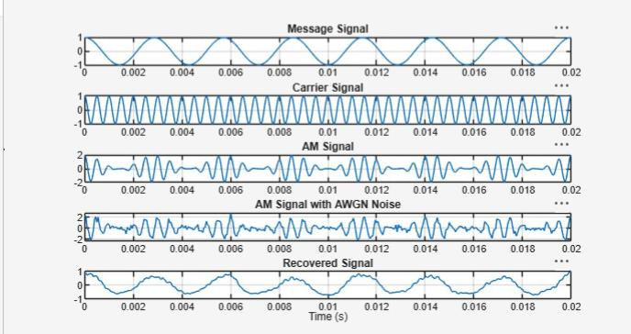

OUTPUT:
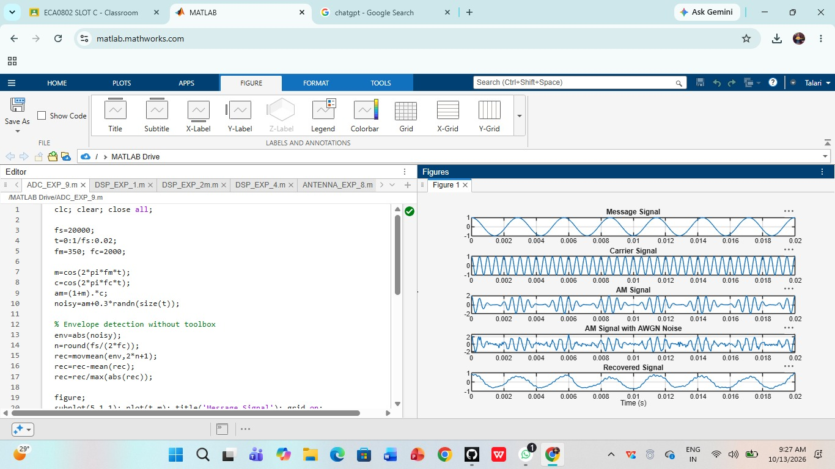
RESULT:
AM signal generation and detection under noisy channel conditions were successfully simulated using MATLAB. The effect of noise on the received signal was analyzed, and the original message signal was recovered through demodulation.

